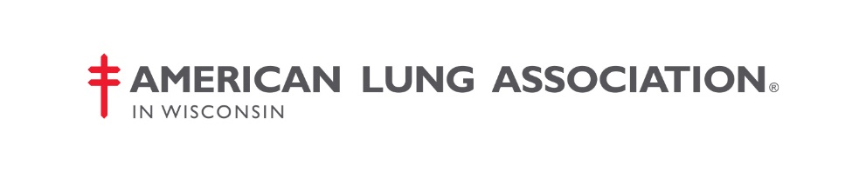

**AB422/SB364 Tobacco 21**

**Position of the American Lung Association**

Tobacco use is a serious health hazard, causing or worsening a wide range of adverse health effects, including lung cancer, respiratory infections, and asthma. Adolescents and young adults are uniquely vulnerable to the effects of nicotine and nicotine addiction, causing lasting, adverse consequences on brain development.[1] A number of states have taken steps to protect their youth from this threat by raising the minimum age of sale for all tobacco products to 21.

**Raising the minimum sales age for tobacco products to 21 years old will significantly reduce youth tobacco use and is very popular among the public.**

* In a 2015 report, the National Academy of Medicine (formerly the Institute of Medicine) found that tobacco use would decrease by 12 percent by the time today’s teenagers were adults and smoking-related deaths will decrease by 10 percent if the minimum age were increased to 21 years.[2]
* Specifically, the National Academy of Medicine predicts that smoking will be reduced by 25 percent for 15-17 year-olds and 15percent for 18-20 year-olds if the tobacco sales age is increased to 21.[3]
* Increasing the minimum sales age to 21 nationwide could prevent 223,000 deaths among people born between 2000 and 2019, including 50,000 fewer dying from lung cancer, the nation’s leading cancer killer.[4]
* An August 2019 Gallup poll found that 73 percent of adults, including 64 percent of current smokers, are in favor of increasing the age of sale to 21.[5]

**AB422 and SB364, as drafted, provide the foundation for a strong law, but need to be amended to address some of the following to earn the American Lung Association’s full support:**

* Clean up the separate and confusing definitions, so that they encompass all tobacco products.
* Require e-cigarette retailers to obtain licenses from the city/county where they do business the same as retailers of other tobacco products are required to do.
* Ensure the fines for underage sales of tobacco products are imposed on the retailer, not on the clerk that made the sale.
* Make compliance checks of retailers mandatory, and stipulate that all retailers need to be checked at least once per year. Current language states that compliance checks “may” be conducted rather than “shall” and do not stipulate that they need to occur once per year for all retailers *.*
* Remove all penalties for youth possession and use of tobacco products.
* State law prevents local governments from taking stronger measures to stop sales of tobacco products to our kids. This preemption should be removed.

The American Lung Association also believes that Tobacco 21 policies must be part of a comprehensive approach that includes high taxes on tobacco products, strong smoke-free and aerosol-free indoor air policies, comprehensive tobacco-control and prevention programs funded at the levels recommended by the Centers for Disease Control and Prevention (CDC) and robust smoking cessation resources to assist tobacco users to quit their addiction for good.

For more information: Dona Wininsky, Director, Advocacy, Grassroots and Patient Engagement – WI

262-703-4840; [Dona.Wininsky@Lung.org](mailto:Dona.Wininsky@Lung.org)

1. U.S. Department of Health and Human Services. The Health Consequences of Smoking – 50 Years of Progress: A Report of the Surgeon General, 2014.
2. Institute of Medicine, Public Health Implications of Raising the Minimum Age of Legal Access to Tobacco Products, Washington, DC: The National Academies Press, 2015, <http://www.nationalacademies.org/hmd/Reports/2015/TobaccoMinimumAgeReport.aspx>.
3. Ibid.
4. Ibid.
5. Gallup. “[Most Americans Support Raising Minimum Age to Buy Tobacco](https://news.gallup.com/poll/262457/americans-support-raising-minimum-age-buy-tobacco.aspx?utm_source=alert&utm_medium=email&utm_content=morelink&utm_campaign=syndication).” August 1, 2019.